COGNIZANT DIGITAL NURTURE 5.0 – DEEPSKILLING
WEEK 1 : Advanced SQL Mandatory Exercises
Submitted By
Name: Muskan Sharma
Email: muskansharma0215@gmail.com
University: C. V. Raman Global University, Odisha
Exercise 1: Ranking and Window Functions
Goal: Use ROW_NUMBER(), RANK(), DENSE_RANK(), OVER(), and PARTITION BY.
Scenario:
Find the top 3 most expensive products in each category using different ranking functions.
Steps:
1. Use ROW_NUMBER() to assign a unique rank within each category.
2. Use RANK() and DENSE_RANK() to compare how ties are handled.
3. Use PARTITION BY Category and ORDER BY Price DESC.
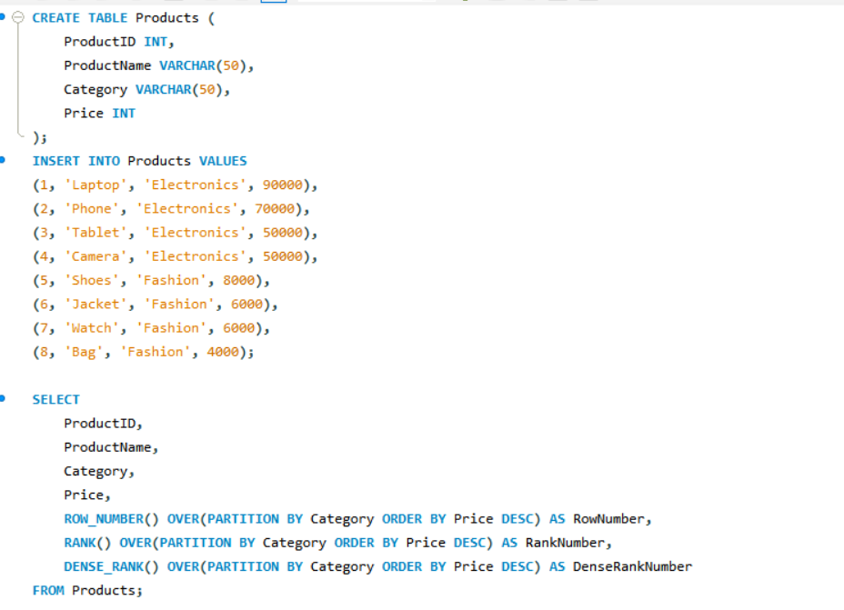
Solution

